1. Create a class Vehicle and encapsulate the data members.

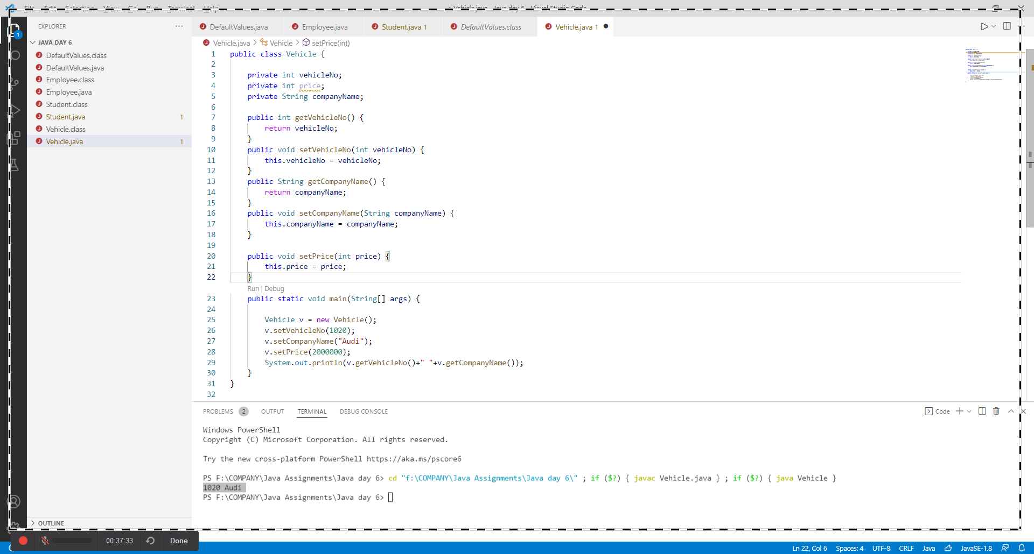

1. Create demo applications to illustrate different types of inheritance.

Single Inheritance:

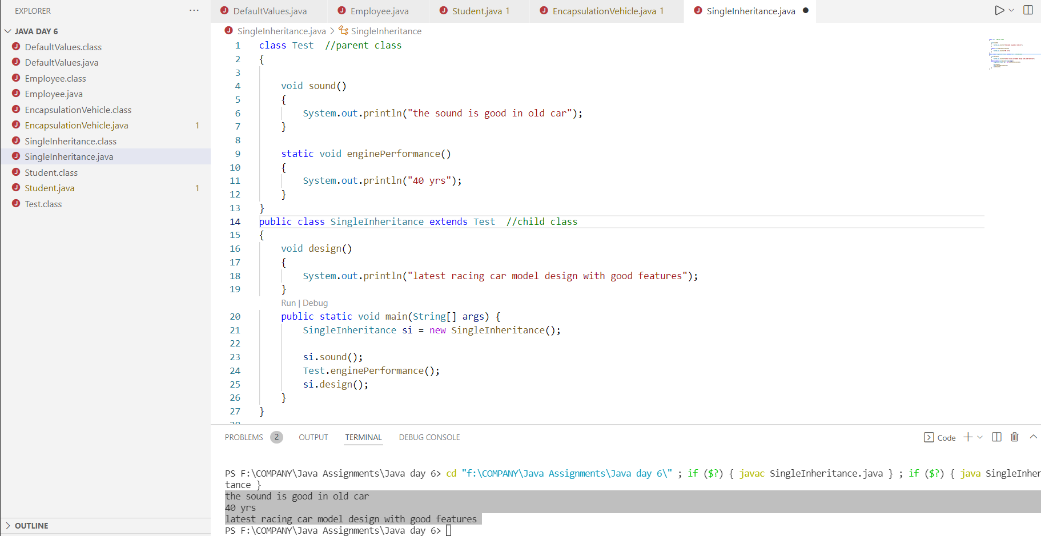

Multilevel Inheritance:

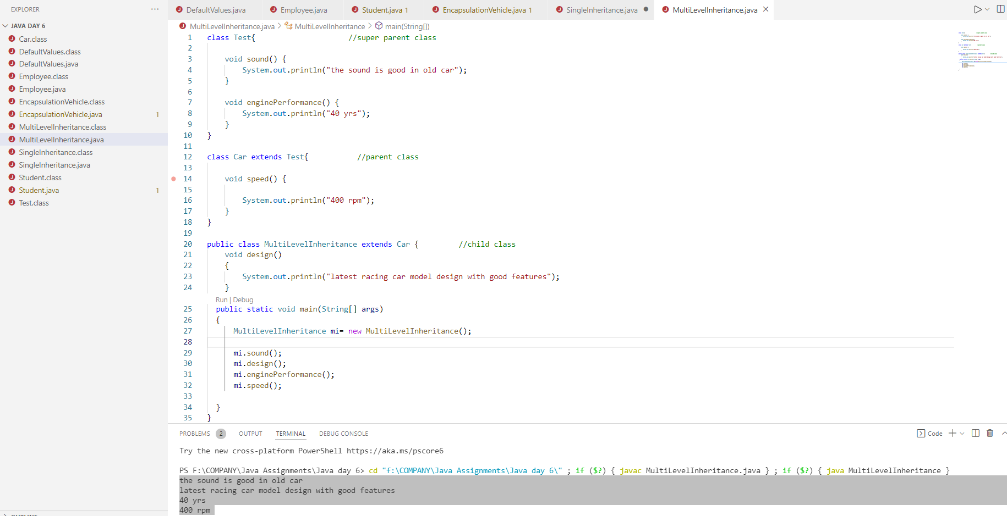

Hierarchical Inheritance

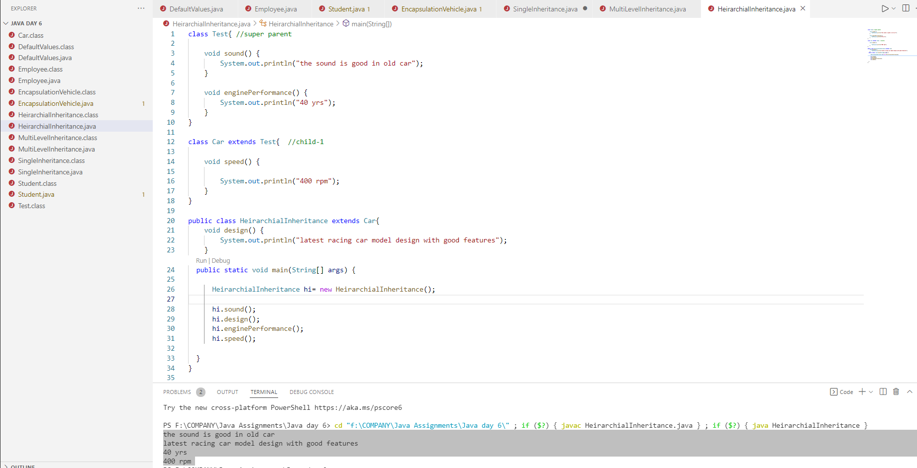

1. Create one Animal class(superclass), Dog class(subclass) the same method in the subclass override the method in the superclass.

